<https://www.transparencymarketresearch.com/immersive-technologies-market.html>

- The immersive technologies market is projected to surpass US$ 2.6 Trn by 2031

- According to Transparency Market Research’s latest research report on the global immersive technologies market for the historical period of 2018–2020 and the forecast period of 2021–2031, increase in adoption of immersive technologies in industrial training and product development are factors expected to boost the global immersive technologies market during the forecast period

* In terms of revenue, the global immersive technologies market was valued at US$ 81.82 Bn in 2020, and is expected to cross US$ 2.6 Trn by 2031, expanding at a CAGR of ~38% during the forecast period

- Virtual Museum Tours, Field Trips Transforming Education Sector

The immersive technologies market is slated to register an explosive CAGR of ~38% during the forecast period. The immersive technology has the possibility to improve a student’s learning experience, while teaching them to embrace technology. From virtual field trips on the planet Mars to roleplaying as history’s greatest public figures, the use of [VR in education](https://www.transparencymarketresearch.com/virtual-reality-in-education-market.html) is helping to make learning more entertaining, especially with distance education during the ongoing pandemic.

The Unimersiv app and Oculus Rift headset are being highly publicized to help students meet people from any country in the world and learn languages in VR. Virtual museum tours are helping students to be vividly immersed in arts and culture. The lesser known topics such as human chemistry are gaining attention with the InMind2’s scientific VR game, which helps students to learn about human chemistry in a fun and safe environment.

<https://www.globenewswire.com/news-release/2022/09/12/2514096/0/en/Immersive-Technologies-Market-is-estimated-to-be-US-1491-07-bllion-by-2020-with-a-CAGR-of-38-4-during-the-forecast-period-2030-By-PMI.html>

September 12, 2022 08:52 ET | Source: [PMI](https://www.globenewswire.com/en/search/organization/Prophecy%2520Market%2520insights)

Covina, Sept. 12, 2022 (GLOBE NEWSWIRE) -- Immersive Technologies Market accounted for US$ 81.82 billion in 2020 and is estimated to be US$ 1491.07 billion (1.4Trn) by 2030 and is anticipated to register a CAGR of 38.4%.

<https://www.adroitmarketresearch.com/industry-reports/immersive-technology-market>

Oct 2021

In terms of revenue the global immersive market is expected to exceed USD 22.4 billion by 2028 with and annual growth rate of approximately 26% by from 2018 to 2028. This impressive growth projection can be attributed to increasing reliance on advanced technology tools such as Augmented Reality (AR), Virtual Reality (VR), and Mixed Reality (MR) to carry business and day-to-day operations.

The key players in the global immersive technology market are Sensics, Samsung Electronics, Microsoft, HTC, Facebook, CyberGlove, Barco, and Sixense Enterprises among all other start-ups and well-established firms. The companies have come up with a range of products into the global immersive technology market in the historical years. These tech giants have done large investments and acquisitions which suggest that immersive technology will become increasingly integrated with today’s platforms.

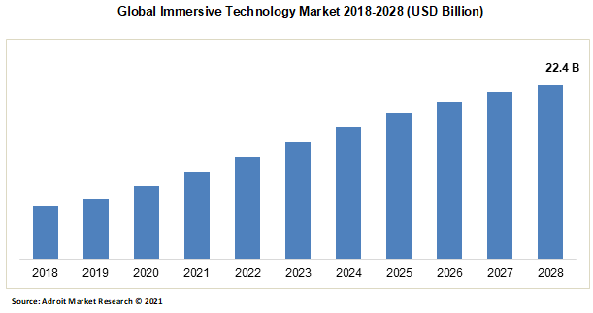

How is chip shortage affecting the VR industry

<https://www.waferworld.com/post/how-chip-shortage-impacted-gaming-industry>

<https://en.wikipedia.org/wiki/2020%E2%80%93present_global_chip_shortage#Causes>

(why there’s a chip shortage)

More sources:

<https://link-springer-com.libproxy.abertay.ac.uk/book/10.1057/9780230363410#toc>

<https://www.tandfonline.com/doi/pdf/10.1080/00043125.2003.11654348>

<https://link.springer.com/referenceworkentry/10.1007/978-94-007-6165-0_296-4>

<https://www.archimuse.com/publishing/interactive_multimedia/interactive_multimedia_design.pdf>

<https://www.museumnext.com/article/how-museums-are-using-augmented-reality/>